PFC - Workshop 04

Q1 (8 marks). Write a program that performs the following tasks:
- Write function with prototype
double myExp(double x, int n);
which calculate e^{x} approximately by the formula:
e^{x} ~ S = 1+ 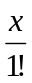 + 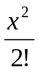 + ... +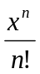

- Write function with prototype
double myExp(double x, double epsi);
which calculate and return e^{x} approximately by the formula:
e^{x} ~ S = 1+ + + ... +
here n is the first integer for which | | ≤ epsi is satisfied.
You should use the main function below to test your program:
int main()
{system("cls");
double x, epsi; int n;
x = 1.5; epsi = 0.00001; n = 1000;
printf("\n");
printf(" exp(%.1f) = %f\n", x,exp(x));
printf(" exp(%.1f,%d) = %f\n", x, n, myExp(x,n));
printf(" exp(%.1f,%f) = %f\n",x, epsi, myExp(x,epsi));
printf("\n");
system("pause");
return(0);
}

Output for the above main function:
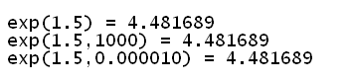

Additional questions (2 marks):
Q2. Write function with prototype:
double myPi(double epsi);
which calculates and return the value PI approximately by the formula:
π ~ S = 4* (1-+-+...+(-1)^{n} 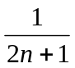)
here n is the first integer for which | | ≤ epsi is satifasfied.

Q3. Write function with prototype:
double mySin(double x, double epsi);
which calculates and return the value sin(x) approximately by the formula:
sin(x) = - 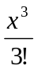 + 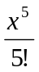 -... +(-1)^{n} 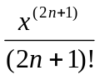
here n is the first integer for which | | ≤ epsi is satisfied.

Q4. Write function with prototype:
double myCos(double x, double epsi);
which calculates and return the value cos(x) approximately by the formula:
cos(x) = 1 - 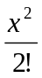 + 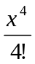 -... +(-1)^{n} 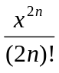
here n is the first integer for which | | ≤ epsi is satisfied.

